INTEGRATED INSTITUTE OF TECHNOLOGY DWARKA





**A MINOR PROJECT BASED ON**

**CAR RENTAL SYSTEM**

## DIPLOMA OF ENGINEERING

**INFORMATION TECHNOLOGY ENABLED SERVICES & MANAGEMENT**

## SUBMITTED TO SUBMITTED BY

**Department of ITES&M Name: - Rahul Jaiswal (BTE-2012111052)**



**2 |** P a g e



# CANDIDATE’S DECLARATION

I hereby declare that the minor project work being presented in this report entitled “**MOTION SENSOR LIGHT SYSTEM**” submitted in the department of **IT ENABLED SERVICES & MANAGEMENT**, FACULTY OF

TECHNOLOGY, **Integrated Institute of Technology, Dwarka, New Delhi 110077** is the authentic work carried out by us under the guidance of **Mr. Nitesh Mathur Sir**, professor of **IT ENABLED SERVICES & MANAGEMENT, Integrated Institute of Technology, Dwarka.**



# INDEX

|  |  |  |
| --- | --- | --- |
|  | Contents | Page No. |
| 1. | Acknowledgement | 4 |
| 2. | Introduction | 5 |
| 4. | About Project | 6 |
| 5. | Hardware Part | 7 |
| 6. | About Components | 8 |
| 7. | Circuit Diagram | 10 |
| 8. | Software Part | 12 |
| 9. | Conclusion | 14 |



**ACKNOWLEDGEMENT**

I would like to express my special thanks of gratitude to my teacher **Ms Kavita Khanna (Campus Director), Mr. Virender Dagar (HOD), Mr. Nitesh Mathur Sir** who gave us the golden opportunity to do this wonderful project on the topic “**Motion Sensor Light System”**, which also helped me in doing a lot of Research and we came to know about so many new things I am really thankful to them.

**Date – 04/11/2022**



# INTRODUCTION

PIR sensors allow you to sense motion. They are used to detect whether a human has moved in or out of the sensor’s range. They are commonly found in appliances and gadgets used at home or for businesses. They are often referred to as PIR, "Passive Infrared", "Pyroelectric", or "IR motion" sensors. Rs are made of pyroelectric sensors, a round metal can with a rectangular crystal in the centre, which can detect levels of infrared radiation. Everything emits low-level radiation, and the hotter something is, the more radiation is emitted. The sensor in a motion detector is split in two halves. This is to detect motion (change) and not average IR levels. The two halves are connected so that they cancel out each other. If one-half sees more or less IR radiation than the other, the output will swing high or low.

# BACKGROUND

The PIR Sensor Switch can detect the Infrared Rays released by the human body. The light or any other electrical appliance can be activated automatically by the active presence of a human body within the detection range/coverage area & when there is no presence the light will be deactivated automatically.



# ABOUT PROJECT

## How do motion sensor lights work?

A Motion sensor light triggers a response when motion is detected. Motion sensor lights are a bit more advanced than your typical lights.

**OR**

A motion detector circuit detects any movement or motion. It has a built- in motion sensor, light sensor, temperature sensor, and most importantly,

ultrasonic sensors. The circuit not only detects movement but also activates alarm signals and lights. Today, many people use the motion detector circuit to ward off intruders.

They can install indoors, on walls, ceilings, and in doorways, or outside, on the exterior of buildings and homes.

## Why Do we need this type of system?

1. For our Convenience
   * No worry to flip a light switch again.
2. For Save Energy
   * The Light automatically turn off when no one is present in the room.
3. To Discourage prowlers and thieves
   * Outdoor motion sensor lights (especially if they’re floodlights or spotlights) can deter criminals. Without darkness to cover their tracks, they may flee from your home.



# HARDWARE PART

1. Arduino UNO
2. PIR Sensor
3. Relay Single Channel
4. Male Female Connector (Jumper Wires)
5. LED
6. Copper Wire
7. Bulb Holder
8. Electric Socket
9. Bulb

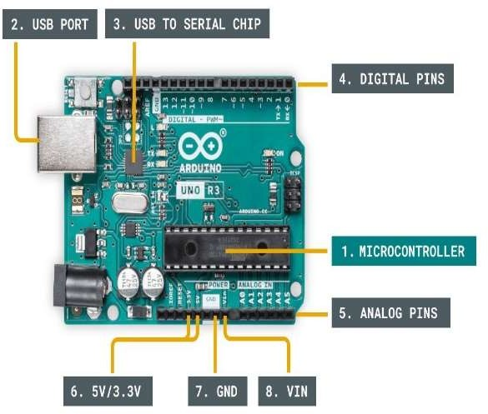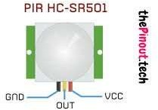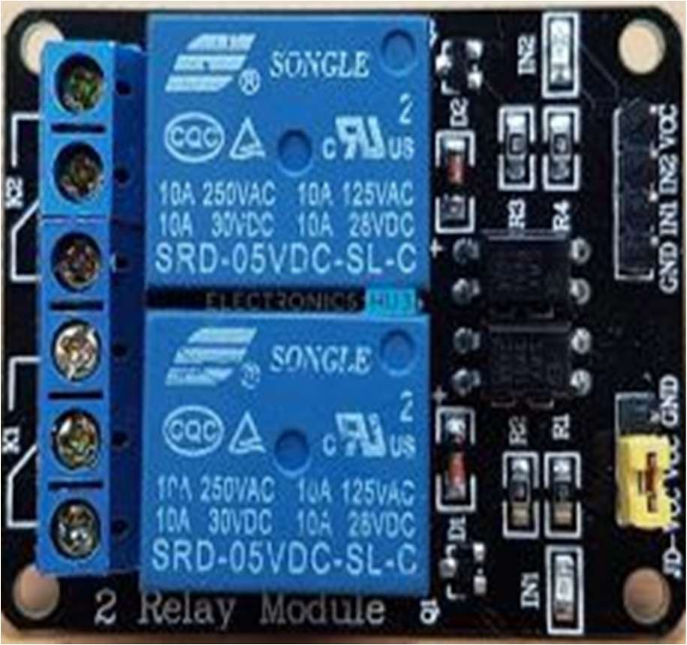



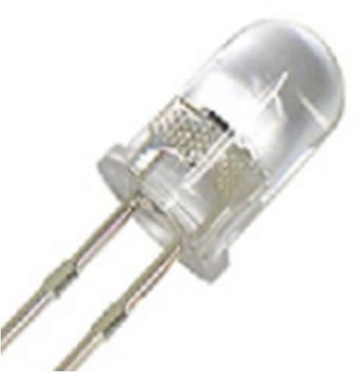 

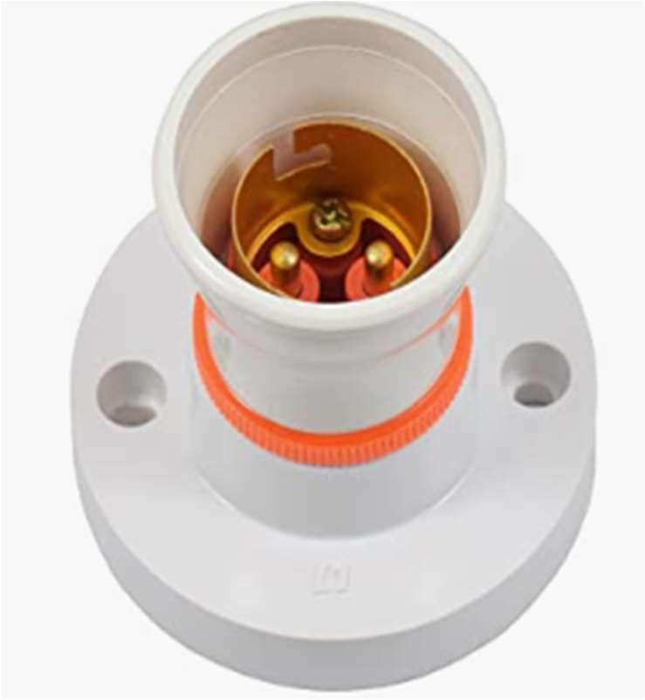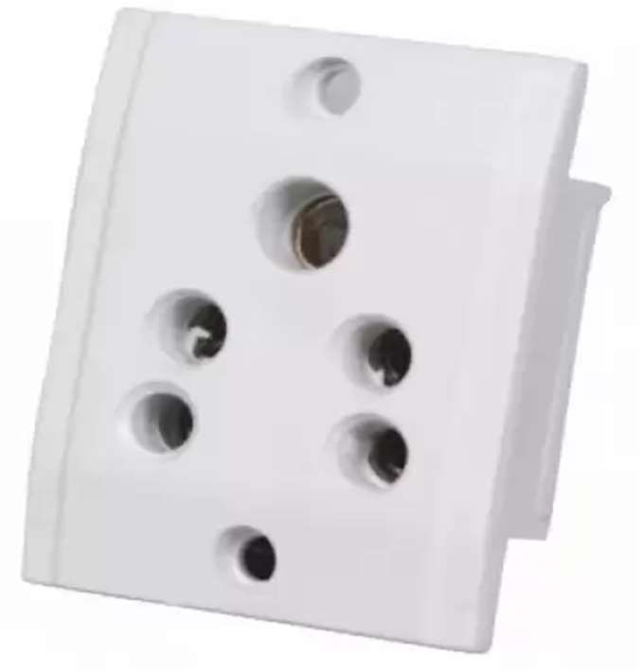

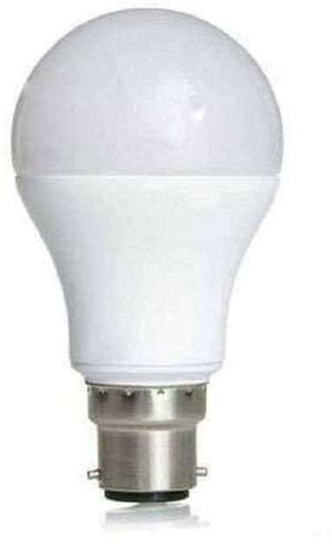



# About Components

**Arduino:-** Arduino is an open-source electronics platform based on easy-to- use hardware and software. Arduino boards are able to read inputs - light on a sensor, a finger on a button, or a Twitter message - and turn it into an output - activating a motor, turning on an LED, publishing something online.

**PIR Motion Sensor:**- PIR sensors allow you to sense motion, almost always used to detect whether a human has moved in or out of the sensors range. They are small, inexpensive, low-power, easy to use and don't wear out. For that reason they are commonly found in appliances and gadgets used in homes or businesses. They are often referred to as PIR, "Passive Infrared", "Pyroelectric", or "IR motion" sensors.

**RELAY:**- A Relay is a simple electromechanical switch. While we use normal switches to close or open a circuit manually, a Relay is also a switch that connects or disconnects two circuits. But instead of a manual operation, a relay uses an electrical signal to control an electromagnet, which in turn connects or disconnects another circuit.



# CIRCUIT DIAGRAM OF MOTION SENSING LIGHT SYSTEM

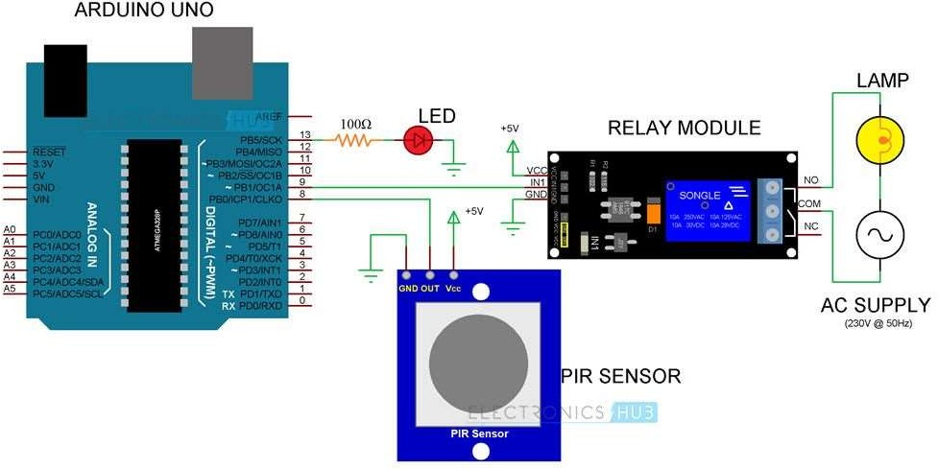

**CONNECTIONS**

## PIR TO Arduino

1. OUT to PIN-8 (socket No-9)(L)
2. vcc to 5V+
3. GND to GND(R)

## Relay To Arduino

1. IN 1 to PIN-9 (socket 10)(L)
2. VCC to 5V+(R)
3. GND to GND(R)

## LED To Arduino

1 - to GND(L)

2 + to 13 pin(L)



# WORKING

The Automatic Room Lights using Arduino and PIR Sensor is a project, where the lights in the room will automatically turn on upon detecting a human motion and stay turned on until the person has left or there is no motion.

When there is no human movement, the PIR Sensor doesn’t detect any person and its OUT pin stays LOW. As the person enters the room, the change in infrared radiation in the room is detected by the PIR Sensor.

The output of the PIR Sensor becomes HIGH. Since the Data OUT of the PIR Sensor is connected to Digital Pin 8 of Arduino, whenever it becomes HIGH, Arduino will activate the relay by making the relay pin LOW (as the relay module is an active LOW module).

This will turn the Light ON. The light stays turned ON as long as there is movement in front of the sensor.

If the person takes a nap or leaves the room, the IR Radiation will become stable (there will be no change) and hence, the Data OUT of the PIR Sensor will become LOW. This in turn will make the Arduino to turn OFF the relay (make the relay pin HIGH) and the room light will be turned OFF.

# APPLICATIONS

* Study Lamp
* Storeroom Light
* Garage Lights
* Bathroom Lights
* Hand Dryers
* Toilet Flushers
* Security Lights



# SOFTWARE PART

**Program for Arduino uno**

int in1 = 9;

int sensor = 8; int led = 13;

unsigned long t=0;

void setup() { Serial.begin(9600); pinMode(in1, OUTPUT); pinMode(sensor, INPUT); pinMode(led, OUTPUT);

digitalWrite(in1,HIGH); digitalWrite(led,LOW);

while(millis()<13000){ digitalWrite(led,HIGH); delay(50); digitalWrite(led,LOW); delay(50);

}

digitalWrite(led,LOW);

}



void loop() { digitalWrite(in1,HIGH); digitalWrite(led,LOW); if(digitalRead(sensor)==HIGH){ t=millis(); while(millis()<(t+5000)) { digitalWrite(in1,LOW); digitalWrite(led,HIGH);

if((millis()>(t+2300))&&(digitalRead(sensor)==HIGH)) { t=millis();

}

}

}

}



# CONCLUSION

The diagram of the motion sensor circuit truly makes the construction easy to assemble. To build a motion detector light circuit, you’ll need LED. At the same time, for an alarm circuit, you’ll need a buzzer. Keep in mind that, despite how careful you are, mistakes may occur.

But in the end, you’ll find the process intriguing and insightful. Today motion sensors are an important element of the security and light system. With the instructions above, you can install it DIY.

Now a days huge amount of power is misused in daily life just for the reason that of human trend of presence lethargic. From the survey it is known that 1 unit of power protected is equal to the 1 unit of power manufactured. So this misused energy can be preserved and can be contribute to large amount of saving of power using automatic room light control system. In the proposed system first detection of human being entering in the room can be done through already existing Ultrasonic sensor but its cost is very high as compared to the PIR sensors. The total effective cost of proposed system is very low as compared to existing system for home and offices